|  |
| --- |
| **Lockedme.com**  **(Application Screenshots)** |

**Version History:**

|  |  |
| --- | --- |
| Author | **Aman Kumar** |
| Purpose | **Screenshot of the application** |
| Date | **12/08/2021** |
| Version | **1.0** |

Table of Contents

1. Main Menu Screenshot 3

2. Display all file: 4

3. Add New File: 5

4. Delete file: 6

5. Search file: 7

6. Exit 8

# Main Menu Screenshot

1. **Screenshot from Eclipse**

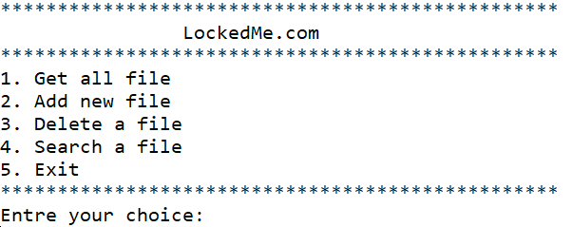

1. 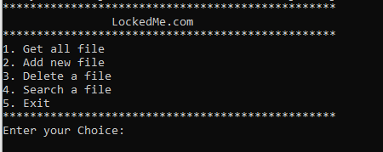**Screenshot from Runnable JAR file (cmd):**

# Display all file:

1. **Screenshot from Eclipse**

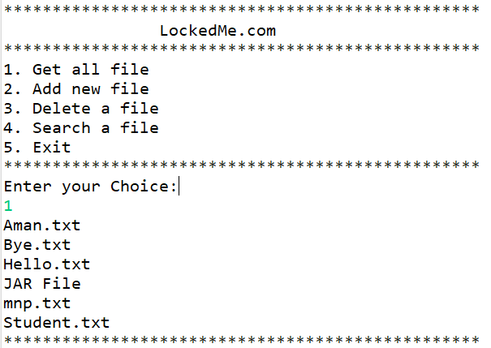

1. **Screenshot from Runnable JAR file (cmd):**

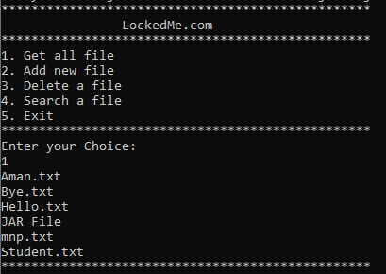

# Add New File:

1. **screenshot from Eclipse**

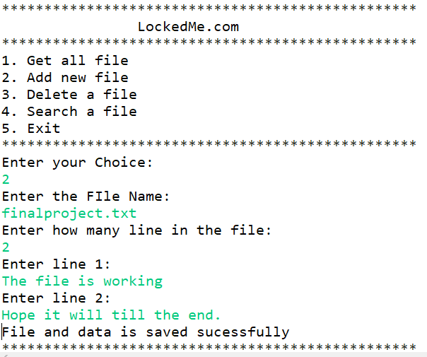

1. **Screenshot from Runnable JAR file (cmd):**

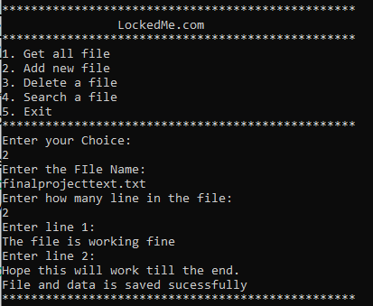

# Delete file:

1. **screenshot from Eclipse**

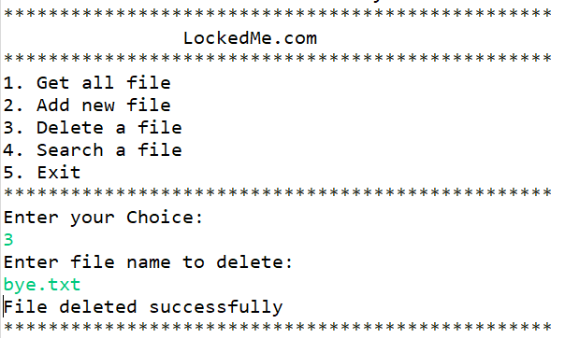

1. **Screenshot from Runnable JAR file (cmd):**

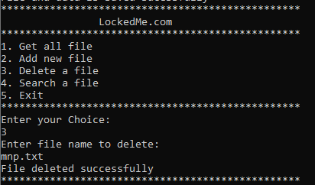

# Search file:

1. **screenshot from Eclipse**

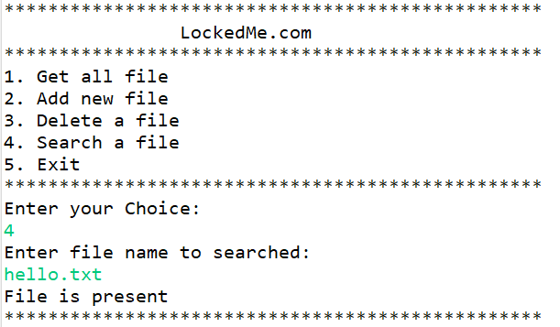

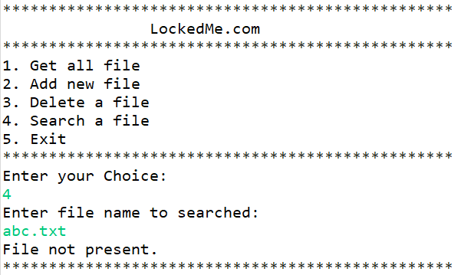

1. **Screenshot from Runnable JAR file (cmd):**

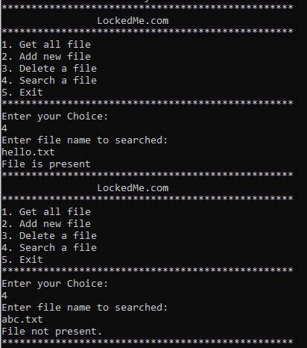

# Exit

1. **screenshot from Eclipse**

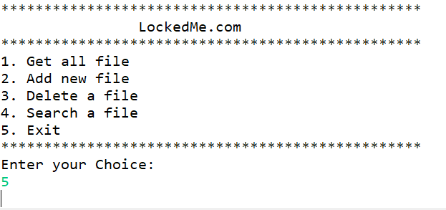

1. **Screenshot from Runnable JAR file (cmd):**

